Primary
Competition Handbook

September 2022 – July 2023

Follow us on Twitter @ER_SSP_West
Visit our website www.eastridingssp.co.uk

This competition handbook features details on the following sports:

- ATHLETICS – QUAD KIDS
- ATHLETICS – SPORTSHALL
- BENCHBALL
- CRICKET –KWIK CRICKET
- CROSS COUNTRY
- DANCE
- DODGEBALL
- FOOTBALL
- GOLF
- NETBALL – BEE
- ORIENTEERING
- ROUNDERS
- RUGBY –TAG
- SWIMMING
- TENNIS

General Competition Reminders:

Schools will need to warm up their own competitors.
All need to come dressed for the weather.
All competitors should bring a water bottle.
Teachers should be aware of any pupils who cannot be photographed and inform the SSCO/competition lead at the start.
All schools should bring a first aid kit, emergency contact list and any appropriate medication for pupils.
All staff are expected to understand the School Games Values and play in lead through example with a superb sporting attitude and showing respect to any officials or young leaders through the event.
Partnership Development Manager Contact Details:
Amanda Jack
Email - pdm@cottinghamhigh.net
Tel – 07759 370043

ATHLETICS – QUAD KIDS

www.quadkids.org

- Year 3/4 team of 4 boys & 4 girls
- Will all do the following 4 events
50m sprint
400m run
Mini vortex howler throw – this can be standing or with a run up
Standing Long Jump

- Year 5/6 team of 4 boys & 4 girls
- Will all do the following 4 events
75m sprint
600m run
Vortex howler throw – this can be standing or with a run up
Standing Long Jump
- Points are awards for times and distances recorded and sent to SGO to find our SSP finalists

Where next?

SSP Final
Tuesday 13th June - South Hunsley - 4.15 – 5.45pm

Humber Level 3:
Wednesday 28th June - Costello Stadium 10am-300pm

ATHLETICS – SPORTSHALL

www.sportshall.org

- A Year 3/4 team and a Year 5/6 team of 9-15 boys & 9-15 girls
- They may compete in a maximum of 2 track and 2 field events although allowances may be made at SSCO discretion for small schools.
- There are 6 track and 6 field events.
- Download the ‘Primary School Pack’ from the website for full details and event programme
- ‘Primary Team sheets’ can also be downloaded. These must be completed before arrival at the event with pupil names and the correct number of pupils for each event. These are for your use at the event and not required by the SSCO.
- Some schools find it helps to enlarge the team sheets to A3 and stick them on the wall for pupils to check

Where next?

Cluster winners attend SSP Final:
Tuesday 7th February - South Hunsley School - 4.00-6.00pm

BENCHBALL
- All teams will have 8 members - both boys and girls in year 4 and a team manager (i.e. teacher/parent). Two substitutes may also be part of the team but only 8 will play in a game and the team must be rotated to include the substitutes.

- Games will last for 5 minutes. If the game is finished before the 5 minutes those children should be supervised and instructed to watch the other game(s) taking place.

- The playing area will be marked out as below:

Team 1
Catcher
Team 2
Catcher
O
X
O
X
X
X
O
O
X
X
O

X
O
O
O
X

Team 2
Team 1

- Each team selects a catcher who stands on a bench at the opposite side of the games area. This must be a different person each game.

- A line of cones/markers should be laid across the court in front of each bench (blue lines), no player is to enter these areas (this will be approx 50/75 cm away from each bench). The ball must be passed up the court and then passed up to their team-mate standing on the bench.

- The other 7 players stand behind a coned/marked centre line in order to begin the game. Two players will be selected to stand in the middle and contest for the ball (red O and X) – the ball will be dropped and after one bounce it can be caught (children begin with arms at their side).

- If children throw and the catcher catches the ball without dropping it or falling off the bench; then the person who threw the ball joins the catcher on the bench and becomes a catcher as well e.g. now there would be 2 players on the bench. The ball cannot rebound off of any walls or the bench prior to catching. If the catcher drops the ball or falls off the bench when attempting to catch the ball - the ball is given to the opposite team (blue line re-start).

- If a goal is scored i.e. the catcher catches the ball, the ball is given to the opposite team who begin on the blue line (the first pass is ‘free’, so no interception can be made until the 2nd pass).

- No player can take more than 2 steps with the ball. The ball may be passed between the team (i.e. chest, bounce and shoulder passes) in order to get closer to their catcher(s) who is on the bench. Encourage movement and communication of players who do not have the ball.

- If the ball goes out of play; the team who did not knock it out will gain possession from the side/backline (the ball must be passed back into play before it is passed to the catcher).

- The team will be awarded a point for every member of the team on the bench. The team with most points will be named the winner. Teams will be awarded 3 points for a win, 2 for a draw and 1 for a loss.

Where next?

- Inter SSP Final - Tues 7th March tbc

CRICKET – KWIK CRICKET

- Each team comprises of 8 players. Squads are limited to 10 players.
- Quotas pertaining to mixed sex teams have been abolished.
- Throughout the Tournament each game shall consist of one innings per team, each innings to be 8 overs long.
- The batting side shall be divided into pairs, each pair batting for 2 overs
- Each team starts batting with a score of 200 runs.
- Each time a batter is out, 5 runs are deducted
- A batter may be out bowled, caught, run out, stumped, hit wicket.
- Each player on the fielding side must bowl 1 over of 6 balls
- Bowling will take place from one end only.
- Bowling should be over arm where possible.
- Full rules are available each summer

Regional Development Officer, John Major 07714771632 j.major@yorkshirecb.com

Cricket Development Manager (East Yorkshire & Selby)
James Martin, T: 07595520474 | E: j.martin@yorkshirecb.com

Where next?

Winners will attend the Hull & East Riding Final on:
Friday 23rd June at Beverley Cricket Club, 10.00am-3.00pm

CROSS COUNTRY

- This will be run as a School Teams event for Year 3, 4, 5, 6
- School teams will consist of 4 pupils for each race:
Y3/4 Girls – 4 in a team
Y3/4 Boys – 4 in a team
Y5/6 Girls – 4 in a team
Y5/6 Boys – 4 in a team
- There will be 4 races – Y3/4 girls, Y3/4 boys, Y5/6 girls and Y5/6 boys
- Y3/4 will run between 800-1000m
- Y5/6 will run between 1200-1500m
- An adult from each school will need to record their teams finishing positions and hand this information to their SSCO

Please note: The winning school team from each race will qualify to attend the East Riding final – along with the top 3 individuals in each race (these may already be in your school team)

Where next?
Cluster winners will attend the East Riding Final on:
Tuesday 18th October - 4.00pm-5.30pm at Cottingham High School

DODGEBALL

- 2 teams of 6 players each begin the game with one foot or hand touching the end line or wall
- 3 balls begin in the centre zone
- On the referees whistle a maximum of 3 players from each team race to collect a ball from the centre zone
- The balls must be passed back to a teammate within 2m of the back wall or line
- On collecting a ball, the players are free to throw the ball at the opponent, in order to get them ‘OUT’

Playing the Game:
- A Game = 2 minutes
- A Match = Best of 3 or 5 x 2 minute games
- Substitutions are allowed between the 2 minute games
- You can use a ball in your possession to block a thrown ball
- Headshots do not count and both players stay in
- All players have 5 seconds to throw a ball in their possession
- All players are not allowed to roll the ball or deliberately throw the ball out of play

Elimination ‘GETTING OUT’
- Hit by a Dodgeball thrown by an opponent without a bounce
- An opposition player catches a Dodgeball that you have thrown
- Stepping over the centre zone lines
- The ball you are holding is knocked from your hands by an opponent’s throw
- Punching or kicking the ball

The Save Rule:
- You can SAVE a teammate from getting OUT if you catch a ball deflected off him/her without the ball having touched another player or surface

Winning a Game:
- Eliminating all opposition players within 2 minutes
- The team with the most players left on court at the end of 2 minutes

Where next?
- Inter SSP Final Tues 28th March tbc

FOOTBALL

- Football will be run slightly differently in each cluster
- Players must wear shin pads
- GK can kick, throw or roll the ball in the goal area
- Off side and pass back rules do not apply
- There may be separate events for girls and small schools
- Competitions for the East Riding finals take place early in the school year for small schools, girls and boys

Where next?

Cluster winners to be submitted to Matt Simpson and progress to the next rounds on the following:

All @ South Hunsley School 3G pitch 4.30-6pm
LARGE SCHOOL: Wed 19th October
SMALL SCHOOL: Wed 2nd November
GIRLS: Wed 9th November

GOLF – TRI-GOLF

- Competitions for Y5/6 teams
- 8 stations with 4 putting and 4 chipping
- Each school team comprises of 10 players – 5 boys and 5 girls
- Mini version of golf made up of 10 putting, hitting and chipping challenges in a circuit
- Points awarded for each station and added to find winning team

Where next?

SSP Winners to attend the Hull & ER Final:
Friday 30th June at Cottingham Parks Golf Club tbc

NETBALL: BEE Netball
Bee Netball (adaption from former High 5 Netball)
England Netball have re-branded their junior netball formats to 'BEE NETBALL'. The adaption is designed to support the learning of the game in a way that is just right for the child's stage of development, not restrict the playing of the game.
There are 3 stages to Bee Netball:
'Buzzer' – years 1&2, 'Flier' – years 3&4 and 'Stinger' – Year 5&6.
The 'Stinger' format has effectively replaced High 5 Netball. The main rules are the same as for High 5 netball, with the exception that players can now defend the player in possession of the ball with their arms up, at a distance of 0.9m. They no longer have just 1 attempt to intercept the ball.
Squads should still be between 7-9, with maximum of 3 boys in the squad and maximum of 2 boys on court at any time.
The 'off court' roles have changed slightly during the rotations, to engage children when they are not playing on court. Off court roles can be allocated appropriately to the children you are involving, to maximise engagement and to embed the 'Bee Netball Beeliefs': 'Bee fair', 'Bee together', 'Bee proud', 'Bee strong'.
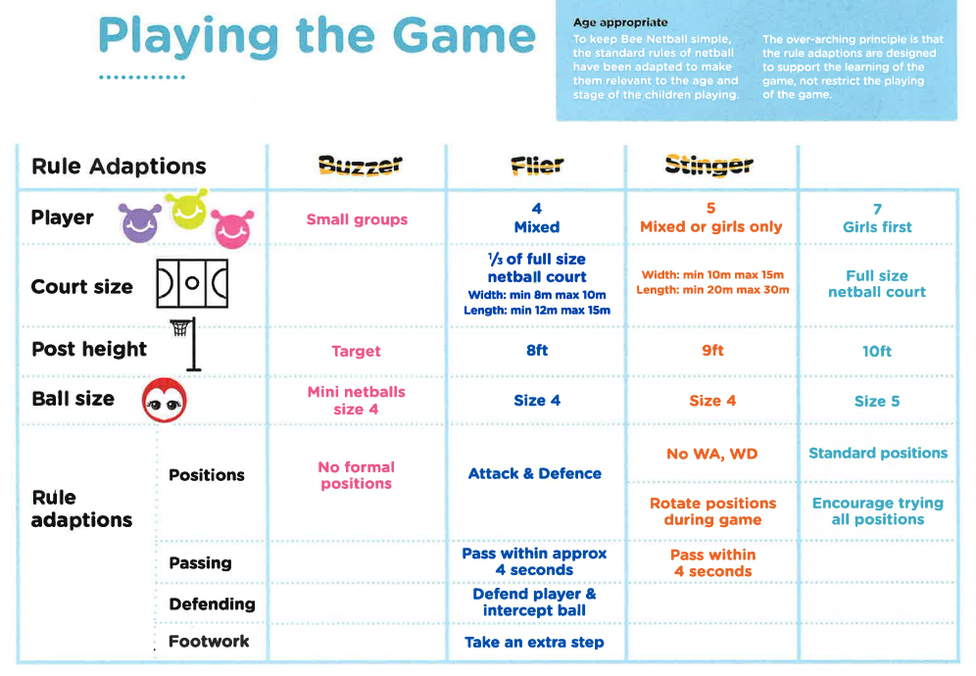

NETBALL: BEE Netball contd

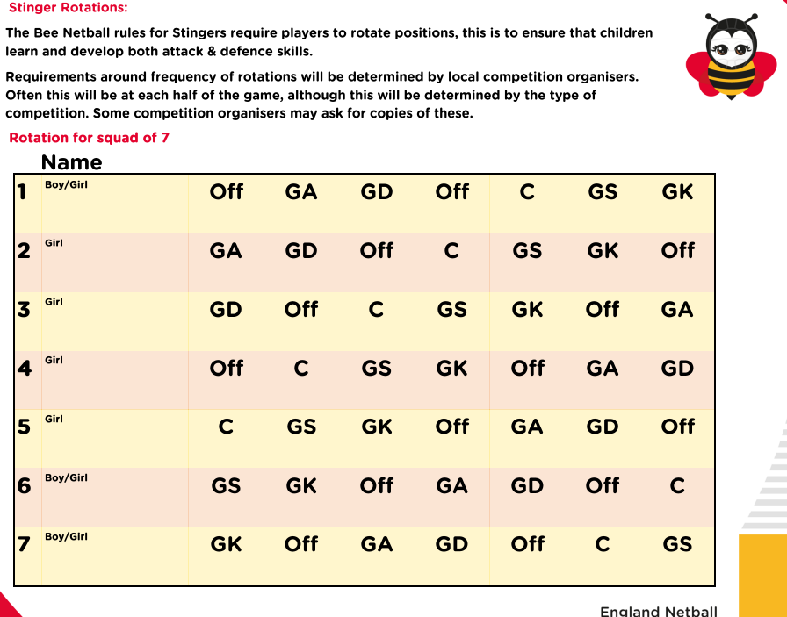

The overview of rules and rotations can be found via this link England Netball | Year 5/6 or at
https://www.englandnetball.co.uk/school-games/year-5-6/

Where next?
Cluster winners to attend the SSP Final:
Tuesday 6th June at Wolfreton - 4-5.30pm

ROUNDERS

- A squad of up to 12 players, with 9 players playing at any one time. The teams are mixed with a maximum of 4 boys on the pitch at any time.
- Use rounders bats and tennis ball
- See ‘your school games level 1 resource – competition card for rules or simplified rules on www.roundersengland.co.uk
- Very Basic Rules
  - Teams can be a minimum of 6 players and a maximum of 15 players. 9 players are on the field for each team at any one time.
  - One team bats while the other team fields and bowls.
  - The bowler bowls the ball to the batter who hits the ball anywhere on the rounders pitch. The batter then runs to as many posts as possible before the fielders return the ball to touch the post the batter is heading for.
  - If the batter reaches the 2nd or 3rd post in one hit, the batting team scores ½ Rounder. If the batter reaches 4th post in one hit, the batting team scores a Rounder.
  - A batter can be out if the fielding team catch the ball hit by the batter before it touches the ground or by touching the post the batter is heading to with the ball before the batter reaches it.

Where next?

Cluster winners to attend the SSP Final on:
Tuesday 20th June - 1-3pm at Cottingham High School

RUGBY

- Each team comprises of 7 players with squads of 12
- Mixed Squads are encouraged
Start of Play
One team starts with the ball which is decided by a coin toss.
Teams line out in their own half

Aim
Aim is to place the ball over the other team's try line, the attacking team must do this by running with the ball and only passing the ball sideways or backwards.

Once a try is scored teams return to half way, losing team takes the free pass to restart

Tagging
The defending team must try and stop this by taking the tag off the attacking player in possession of the ball, holding the tag in the air and shouting ‘TAG’, at this point the tagged must stop and pass the ball. They do not have to put their tag back on before passing the ball.

The pass must be played as close to the point where the tag happened as possible. If the referee deems too much distance is ran after the tag they may be asked to move back to the point.

After a tag the defending team must move back in line with the referee, if not they are offside they cannot take part in play until they get back behind the referee.

Unlimited Tags (no amount of tag create a turn over)

The tagger and taggee are now OUT OF PLAY and do not continue until:
The tagger hands the tag back to the taggee- the taggee MUST reattach their tag before joining in. Once the players have their tags back they join in as usual.

Foul – Free Pass awarded
Knock on - loose control of the ball and it goes forward and hits the floor
Forward pass - Ball is not passed sideways or backwards
In touch - player in possession of the ball is outside the field of play

Restart - play with a tap from the point of the foul

A player may intercept the ball as long as he is onside.

Try Scoring
Players must not dive over the line when scoring a try they must try and stay on their feet (This may result in the try been disallowed)

Direct entry to SSP Event on:
Wednesday 17th May - 1.00pm-3.00pm at Hullensians RUFC

SWIMMING

- Each team comprises of 6 boys and 6 girls
- Swimmers may only enter up to 2 individual races and 2 relays
- 7 events make up this competition

Where next?

Cluster winners to attend the East Riding Final on:
Tuesday 16th May - 9.30am-12.00pm at Beverley Leisure Centre

